Sushmita Das

X D

21

Podar International

Senior Secondary School – ISC, NERUL

Certificate

Sushmita Suraj Das

Student Name ______________________________________

21

D

X

Class _______ Division ______ Roll no _____

Podar International School

***Examination No___________ School____________________________________***

***_______________________________***

***This is to certify that the project work written in the journal has been performed by the student satisfactorily.***

26/11/2020

Date _____________ Grade ________________

_____________________ ____________________

External Examiner Internal Examiner

_____________________ ____________________

School Seal Principal Sign

|  |  |  |
| --- | --- | --- |
| Sr No. | TOPIC | Page No. |
| **1.** | **Floyd Triangle** | **1** |
| **2.** | **Employee** |  |
| **3.** | **Random Numbers** |  |
| **4.** | **Bank Deposit** |  |
| **5.** | **Triangle Patterns** |  |
| **6.** | **ISBN Number** |  |
| **7.** | **Student** |  |
| **8.** | **Park** |  |
| **9.** | **Series 1 & Series 2** |  |
| **10.** | **Pattern 1 & Pattern 2** |  |
| **11.** | **Marks** |  |
| **12.** | **Bubble Sort Technique** |  |
| **13.** | **Temperature** |  |
| **14.** | **Average** |  |
| **15.** | **Last Digit** |  |

1. Floyd Triangle

public class Question1_Floyd_triangle

{

public static void printFloyd (int rows)

{

int number = 1;

System.out.printf("Floyd's triangle of %d rows is : %n", rows);

for(int i = 1;i<=rows;i++)

{

for ( int j =1; j<= i; j++)

{

System.out.print(number +" ");

number++;

}

System.out.println();

}

}

}

When number of rows entered is 4:

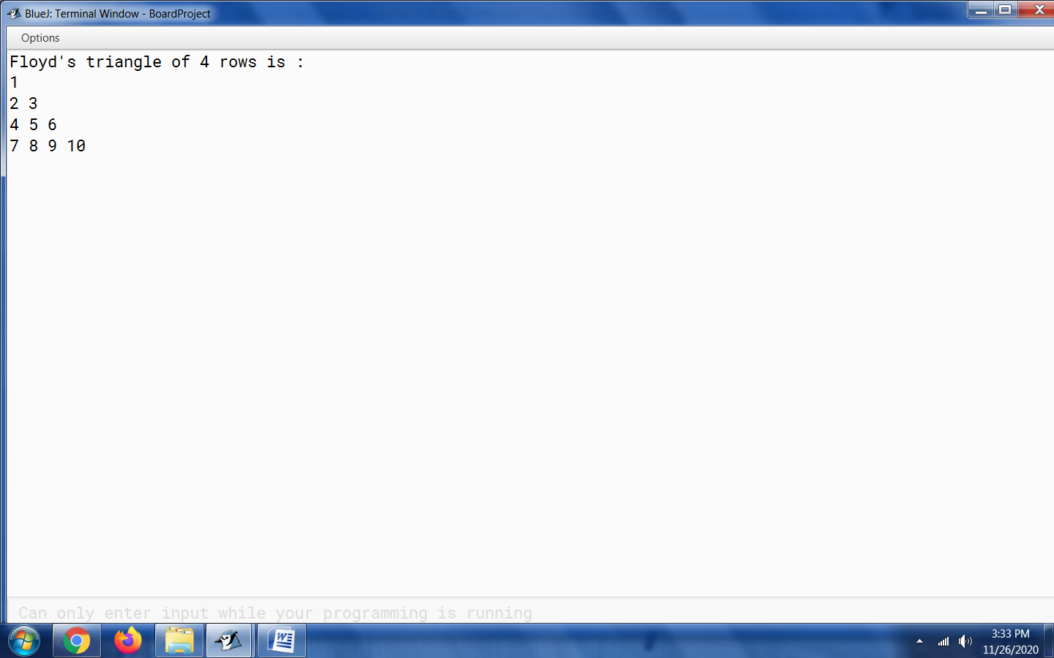When number of rows entered is 10: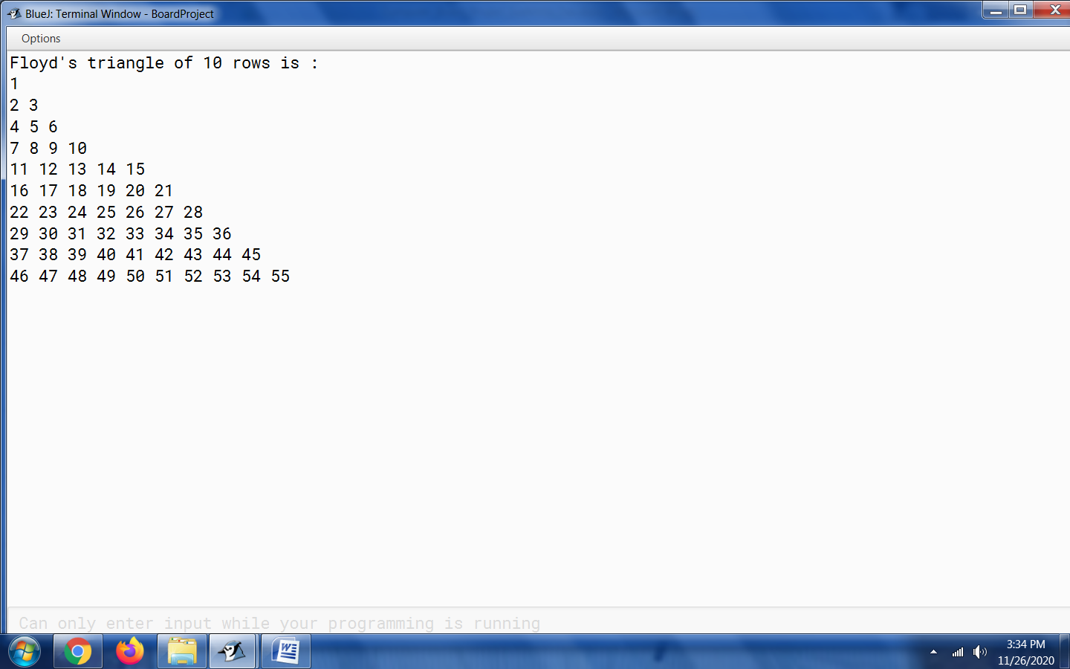

2. Employee

public class Question2_Employee

{

double salary1;

String name_of_employee;

double final_amt;

void init(double salary, String name_of_employee1 )

{

salary1= salary ;

name_of_employee = name_of_employee1;

}

double calc ()

{

final_amt = salary1+((50.0/100.0)*salary1);

return final_amt; //caller

}

String we()

{

String name1= name_of_employee;

return name1;

}

public static void main()

{

Question2_Employee obj = new Question2_Employee();

obj.init(50000,"Sushmita Suraj Das");

double final_amt = obj.calc();

String name1 = obj.we();

System.out.println(final_amt);

System.out.println(name1);

}

}

When salary entered is 50,000:

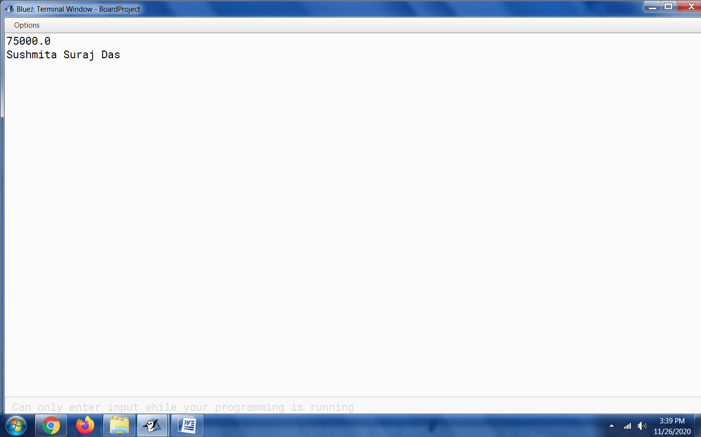

When salary entered is 8,50,000:

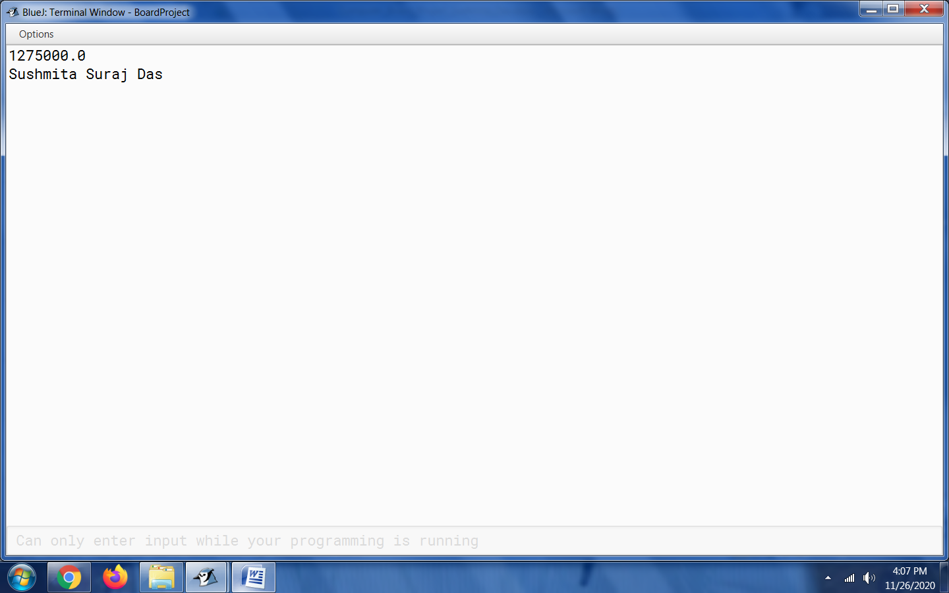

3. Random Numbers

import java.util.Random;

public class Question3_Random_Numbers

{

public static void main(String args[])

{

Random random = new Random();

int random_int1 = random.nextInt(100);

int random_int2 = random.nextInt(100);

int random_int3 = random.nextInt(100);

int random_int4 = random.nextInt(100);

int random_int5 = random.nextInt(100);

int random_int6 = random.nextInt(100);

int random_int7 = random.nextInt(100);

int random_int8 = random.nextInt(100);

int random_int9= random.nextInt(100);

int random_int10= random.nextInt(100);

int random_int11 = random.nextInt(100);

int random_int12 = random.nextInt(100);

int random_int13= random.nextInt(100);

int random_int14= random.nextInt(100);

int random_int15= random.nextInt(100);

int random_int16= random.nextInt(100);

int random_int17= random.nextInt(100);

int random_int18= random.nextInt(100);

int random_int19 = random.nextInt(100);

int random_int20 = random.nextInt(100);

System.out.println("Random Integers: "+random_int1);

System.out.println("Random Integers: "+random_int2);

System.out.println("Random Integers: "+random_int3);

System.out.println("Random Integers: "+random_int4);

System.out.println("Random Integers: "+random_int5);

System.out.println("Random Integers: "+random_int6);

System.out.println("Random Integers: "+random_int7);

System.out.println("Random Integers: "+random_int8);

System.out.println("Random Integers: "+random_int9);

System.out.println("Random Integers: "+random_int10);

System.out.println("Random Integers: "+random_int11);

System.out.println("Random Integers: "+random_int12);

System.out.println("Random Integers: "+random_int13);

System.out.println("Random Integers: "+random_int14);

System.out.println("Random Integers: "+random_int15);

System.out.println("Random Integers: "+random_int16);

System.out.println("Random Integers: "+random_int17);

System.out.println("Random Integers: "+random_int18);

System.out.println("Random Integers: "+random_int19);

System.out.println("Random Integers: "+random_int20);

}

}

Output 1:

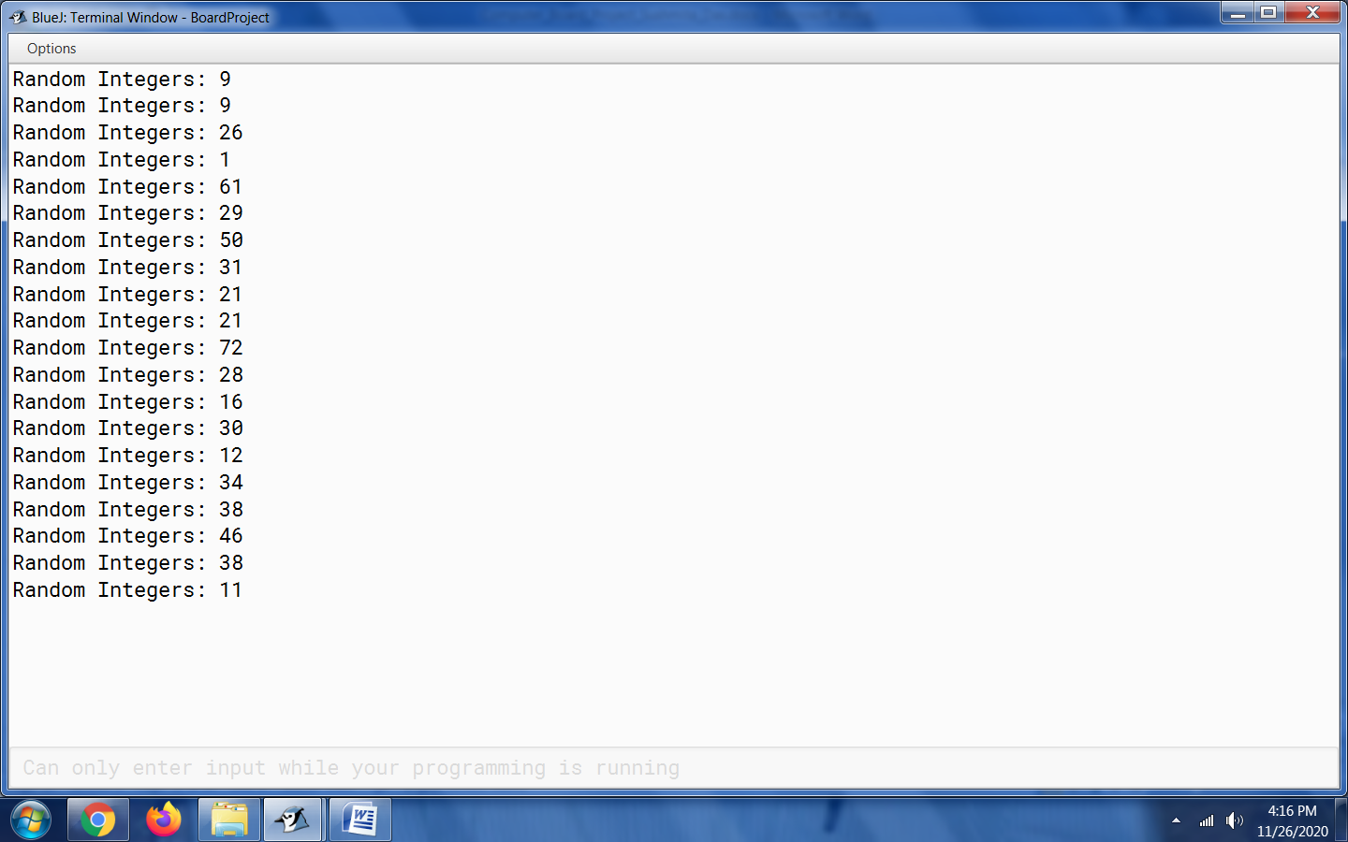

Output 2:

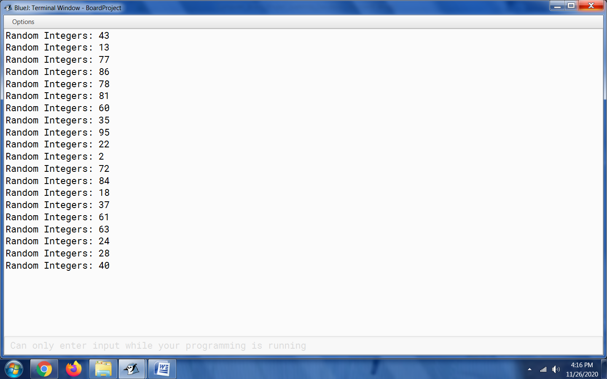

4. Bank Deposit

import java.io.*;

class Question4_Bank_Deposit

{

public static void main(String args[])

throws IOException{

InputStreamReader in = new InputStreamReader(System.in);

BufferedReader br = new BufferedReader(in);

System.out.println("1. Term Deposit");

System.out.println("2. Recurring Deposit");

System.out.print("Enter your choice: ");

int option = Integer.parseInt(br.readLine());

switch(option)

{

case 1:

System.out.print("Principal: ");

double principal = Double.parseDouble(br.readLine());

System.out.print("Rate of interest: ");

double rate = Double.parseDouble(br.readLine());

System.out.print("Time in years: ");

double time= Double.parseDouble(br.readLine());

double maturity_value = principal * Math.pow(1 + rate / 100, time);

System.out.println("Maturity amount: " + maturity_value);

break;

case 2:

System.out.print("Monthly installment: ");

principal = Double.parseDouble(br.readLine());

System.out.print("Rate of interest: ");

rate= Double.parseDouble(br.readLine());

System.out.print("Time in months: ");

time = Double.parseDouble(br.readLine());

maturity_value = principal * time + principal * (time * (time + 1) / 2) * (rate/ 100) * (1.0 / 12);

System.out.println("Maturity amount: " + maturity_value);

break;

default:

System.out.println("Invalid input. Kindly enter either 1 or 2.");

}

}

}

Output Screen before entering an option:

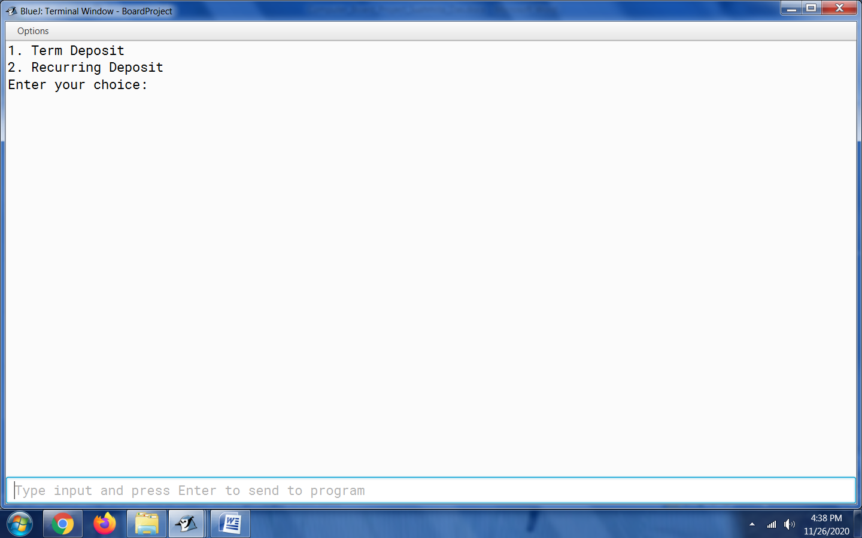

When 1 is entered:

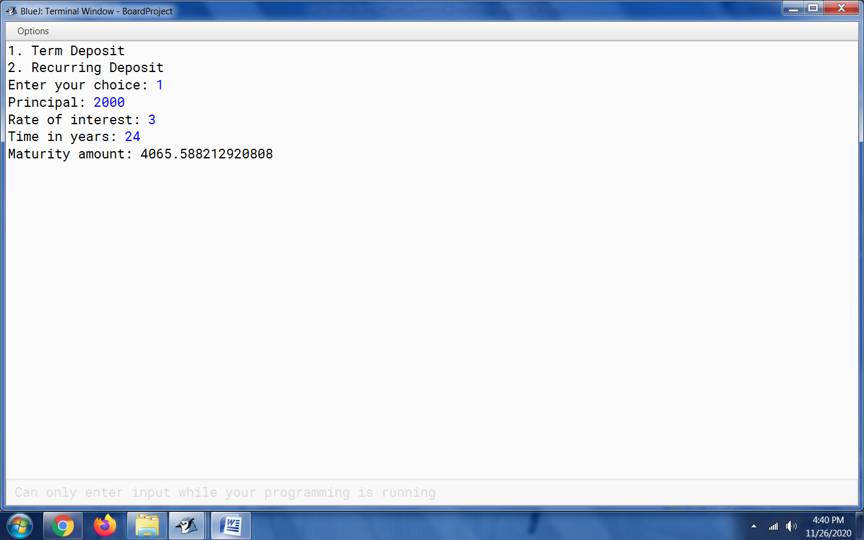

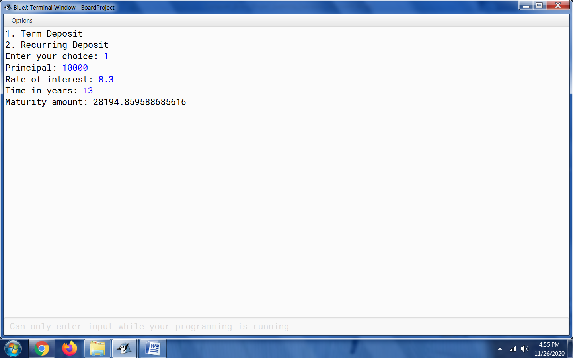

When 2 is entered:

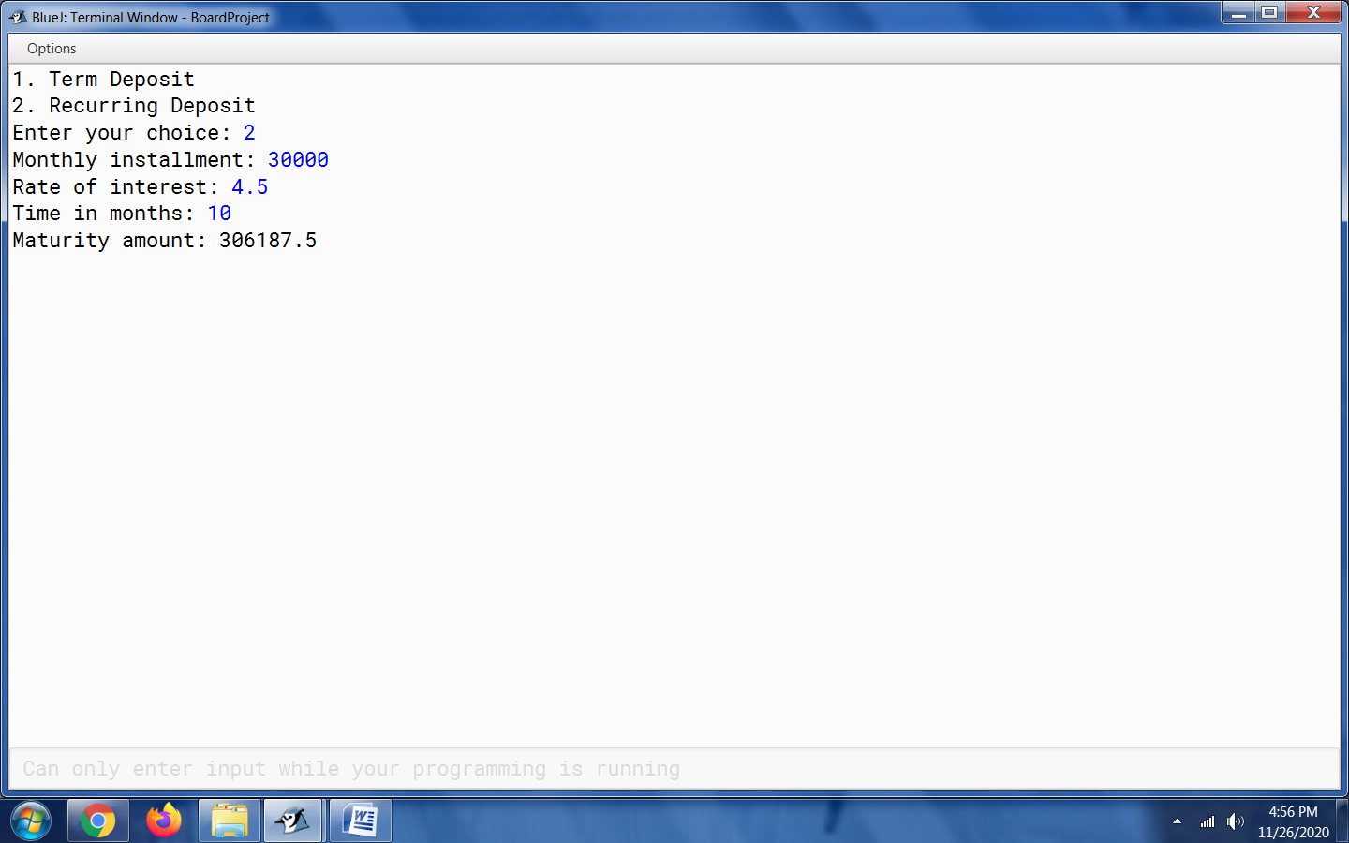

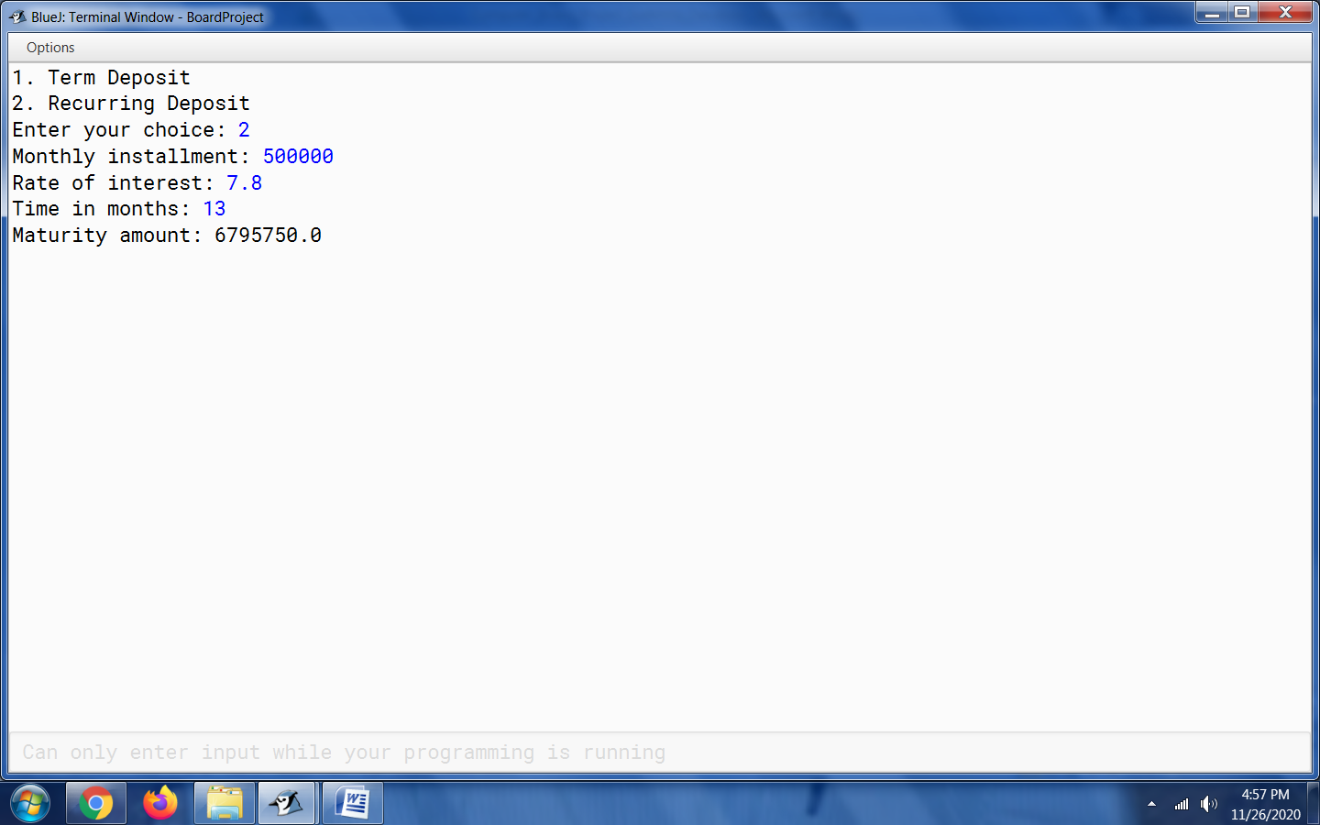

5. Triangle Patterns

import java.io.*;

class Question5_Triangle_Pattern

{

public static void main(String args[])

throws IOException{

InputStreamReader in = new InputStreamReader(System.in);

BufferedReader br = new BufferedReader(in);

System.out.println("1. Ascending Triangular pattern");

System.out.println("2. Descending Triangular pattern");

System.out.print("Enter your choice: ");

int choice = Integer.parseInt(br.readLine());

switch(choice){

case 1:

// Program for Ascending Triangular pattern

for(int i=1;i<=5;i++)

{

for(int j=1;j<=i;j++)

{

System.out.print(j+" ");

}

System.out.println();

}

break;

case 2:

// Program for Descending Triangular pattern

for(int i=1;i<=5;i++)

{

int printval = 5;

for(int j=5;j>=i;j--)

{

System.out.print(printval+" ");

}

System.out.println();

}

break;

default:

System.out.println("Invalid input - Please enter choice as 1 or 2");

}

}

}

Before entering a choice:

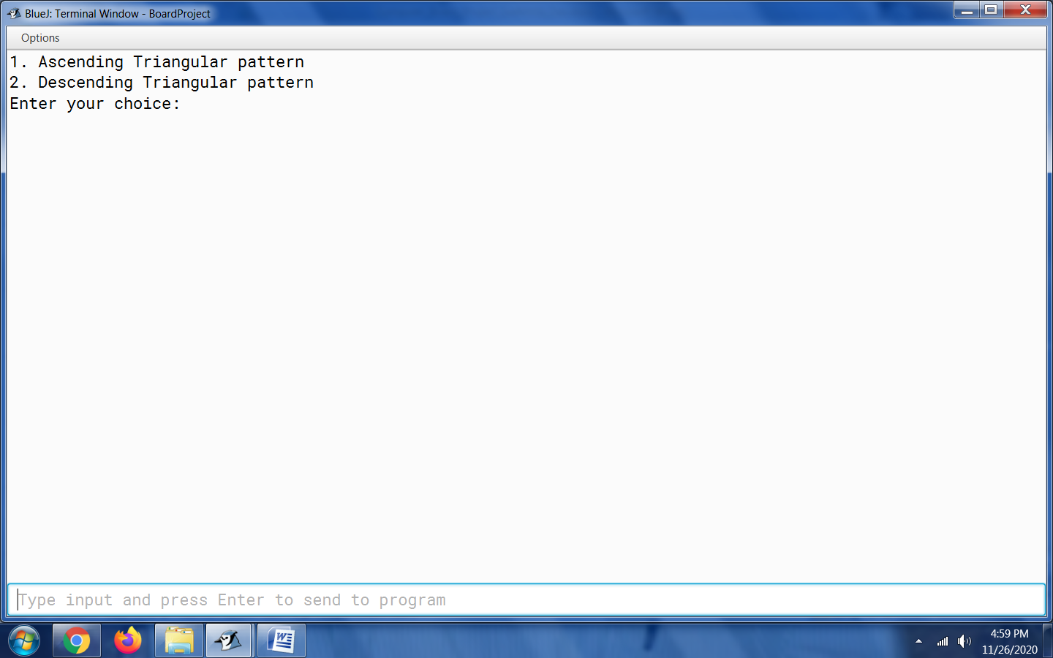

When option 1 is chosen:

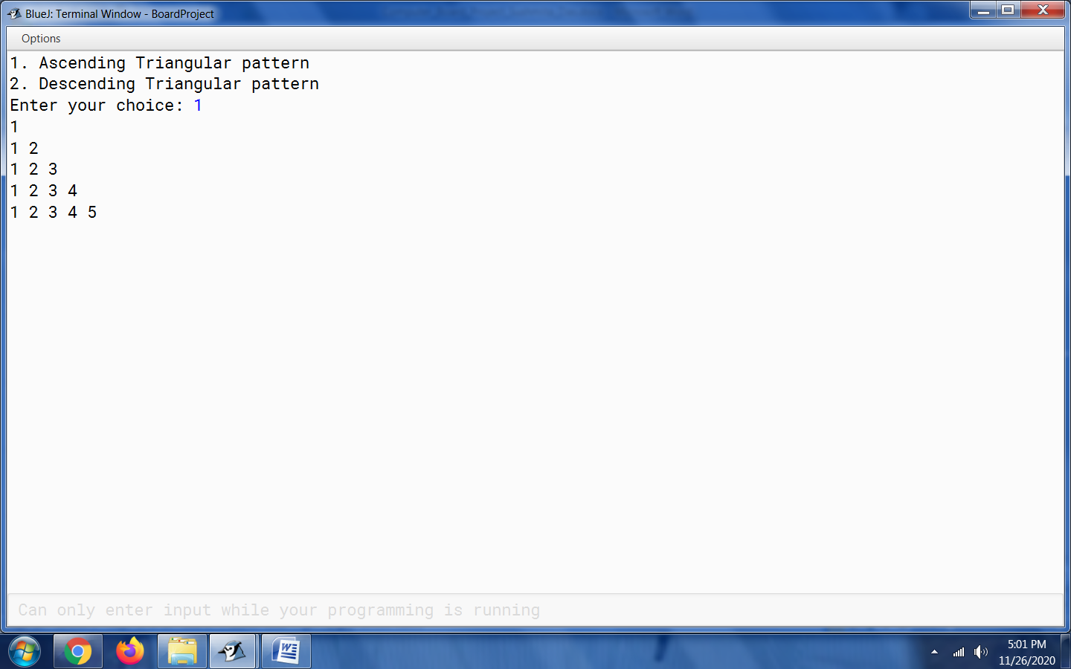

When option 2 is chosen:

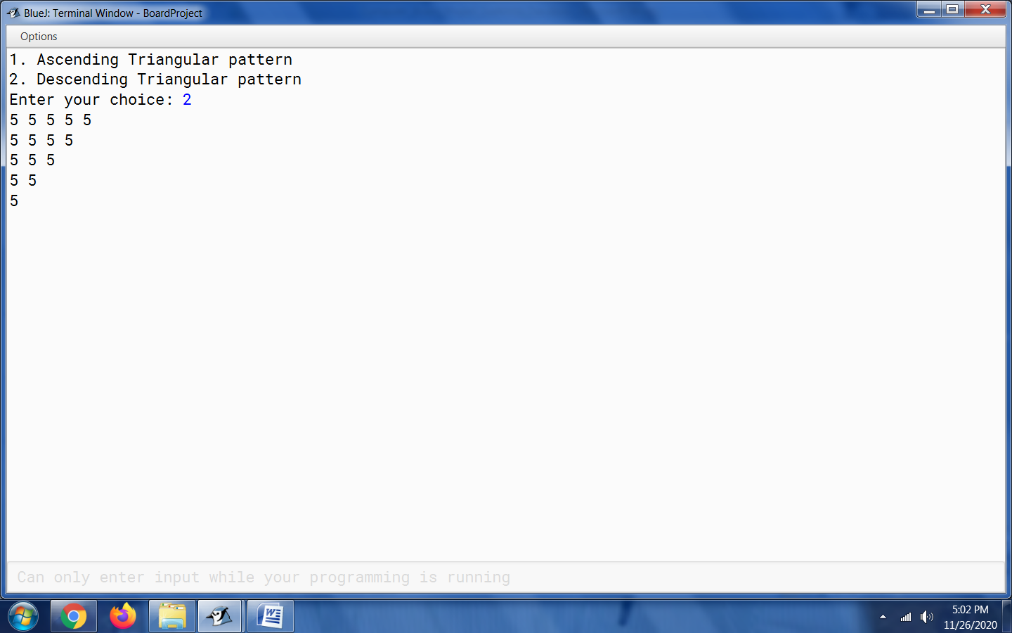

6. ISBN Number

import java.util.*;

public class Question6_ISBN_Number

{

public static void main()

{

Scanner in=new Scanner(System.in);

int ISBN;

int n=0,s=0,a=0,b=10;

System.out.println("Enter ISBN");

ISBN=in.nextInt();

while(ISBN>0)

{

a=ISBN%10;

n++;

s+=a*b;

b--;

ISBN/=10;

}

if(n<10||n>10||s%11!=0)

System.out.println("Illegal ISBN");

else if(n==10&&s%11==0)

System.out.println("Legal ISBN");

}

}

7. Student

import java.util.Scanner;

public class Student

{

    String name;

    int roll;

    int marks1,marks2,marks3,marks4,marks5;

    Scanner sc = new Scanner(System.in);

    void input()

    {

        System.out.println("Enter the name of the student");

        name = sc.nextLine();

        System.out.println("Enter the roll number of the student");

        roll = sc.nextInt();

        System.out.println("Enter the marks scored in subject 1");

        marks1= sc.nextInt();

        System.out.println("Enter the marks scored in subject 2");

        marks2 = sc.nextInt();

        System.out.println("Enter the marks scored in subject 3");

        marks3 = sc.nextInt();

        System.out.println("Enter the marks scored in subject 4");

        marks4 = sc.nextInt();

        System.out.println("Enter the marks scored in subject 5");

        marks5 = sc.nextInt();

     }

    void allotment()

    {

        double avg = (marks1 + marks2 + marks3 + marks4 + marks5)/5.0;

        System.out.println("Average Marks: " + avg);

        if(avg>=90)

        {

            System.out.println("Science with Computers");

        }

        else if(80<=avg && avg<=89)

        {

            System.out.println("Science without Computers");

        }

        else if(70<=avg && avg<=79)

        {

            System.out.println("Commerce with Maths");

        }

        else

        {

            System.out.println("Commerce without Maths");

        }

    }

    void display()

    {

        System.out.println("Name: " + name);

        System.out.println("Roll Number: " + roll);

        allotment();

    }

    public static void main()

    {

        Student obj = new Student();

        obj.input();

        obj.display();

    }

}

Output 1:

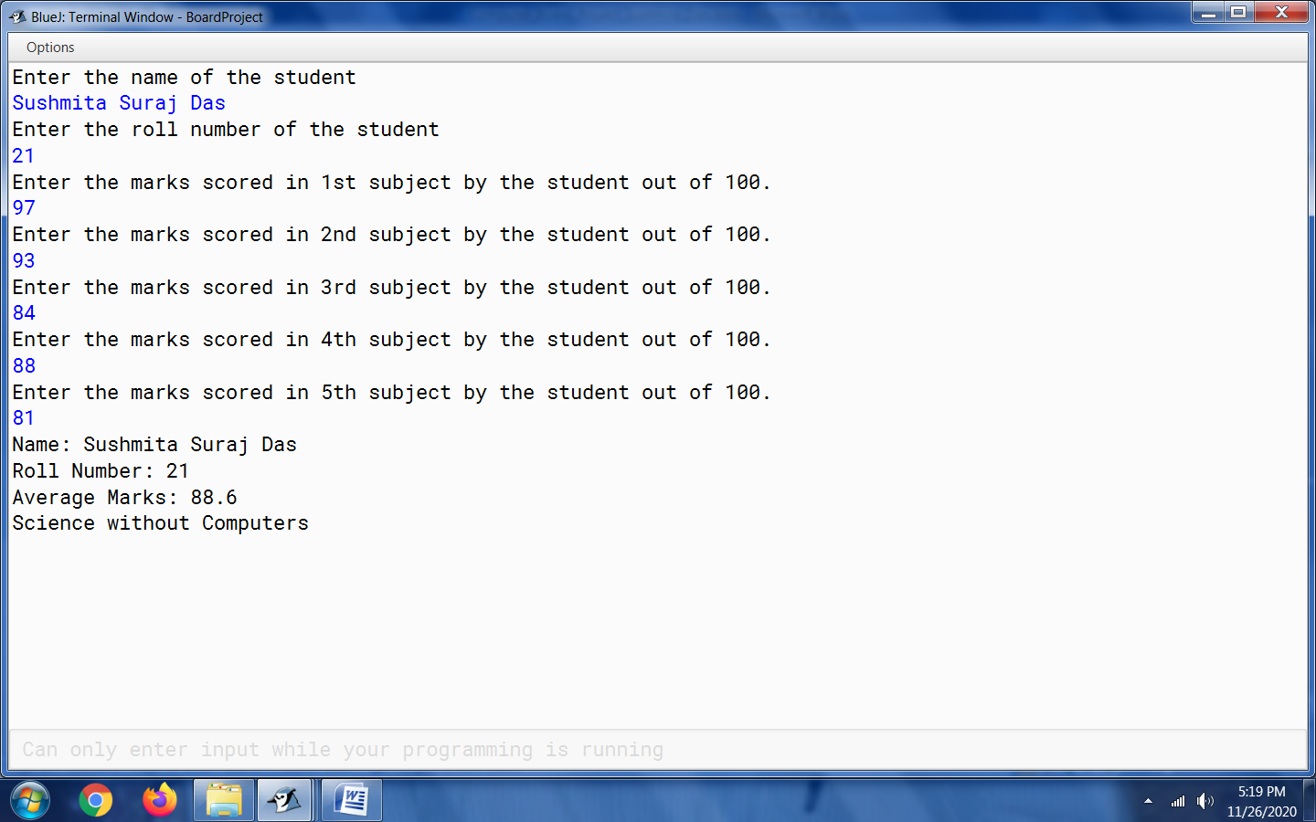

Output 2:

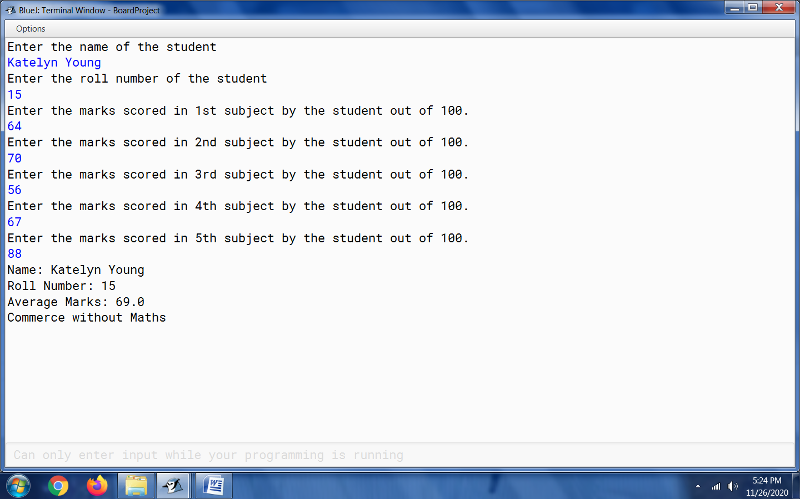

8. Park

import java.util.Scanner;

class Question8_Park

{

double Entryfee,discount,amount;

int age;

void input()

{

Scanner sc=new Scanner(System.in);

System.out.println("Enter Entry Fee");

Entryfee=sc.nextDouble();

System.out.println("Enter Age");

age=sc.nextInt();

}

void calculate()

{

if(age<=12)

{

discount=(45*Entryfee)/100;

amount=Entryfee-discount;

}

else if(age>=50)

{

discount=(50*Entryfee)/100;

amount=Entryfee-discount;

}

else

{

discount=(10*Entryfee)/100;

amount=Entryfee-discount;

}

}

void display()

{

System.out.println("The total amount= Rs"+amount);

}

public static void main()

{

Question8_Park obj=new Question8_Park();

obj.input();

obj.calculate();

obj.display();

}

}

Output 1:

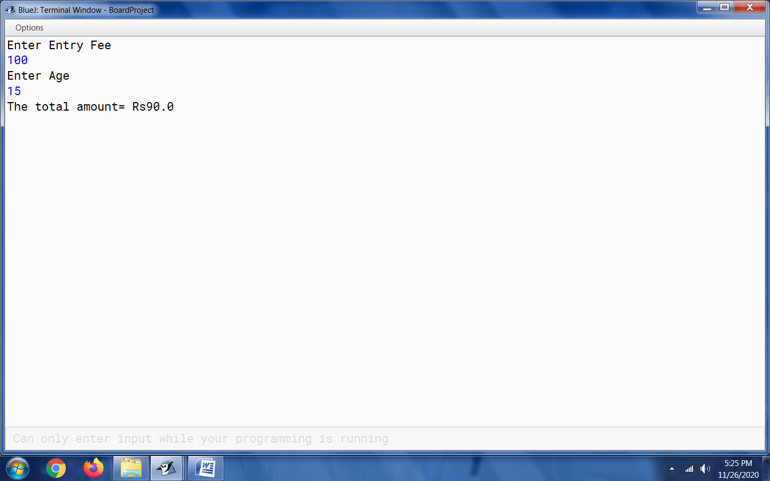

Output 2:

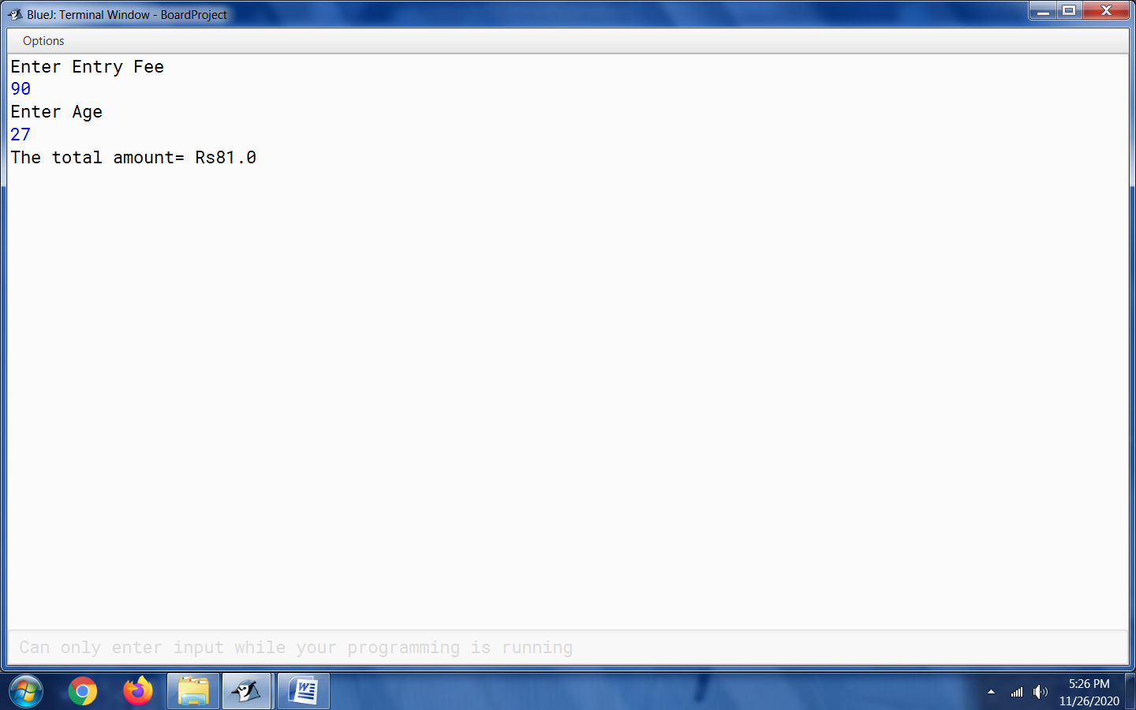

9. Series 1 & Series 2

* Series 1

public class Question9_Series1

{

public static void main (String args [])

{

int sumOfSeries = 0;

int i = 2;

while(i<=20)

{

if (i%4==0)

{

sumOfSeries = sumOfSeries - i;

}

else

{

sumOfSeries = sumOfSeries + i;

}

i = i+2;

}

System.out.println("Sum of the series is " + sumOfSeries);

}

}

Output:

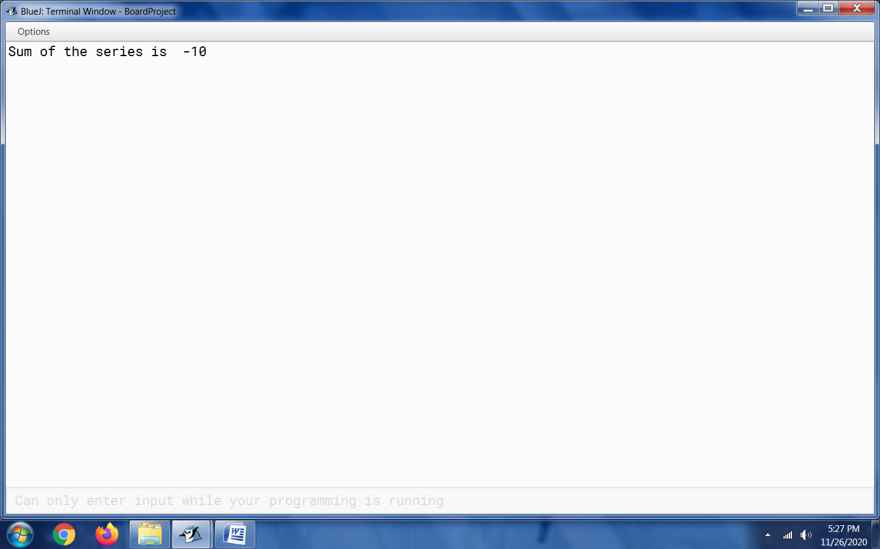

* Series 2

public class Question9_Series2

{

public static void main (double x)

{

double s = 0;

double n = 2;

for(int i = 2; i<=7; i++)

{

s = s+x/n;

n=n+3;

}

System.out.println(s);

}

}

Output 1:

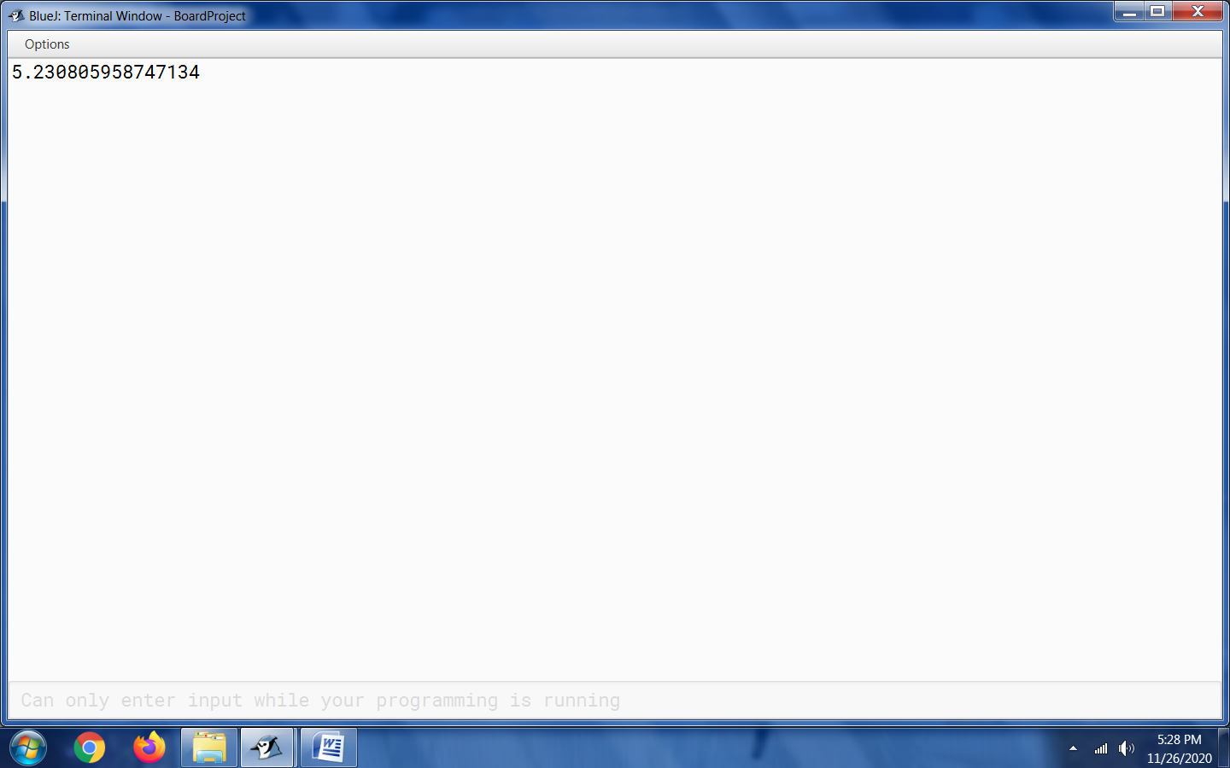

Output 2:

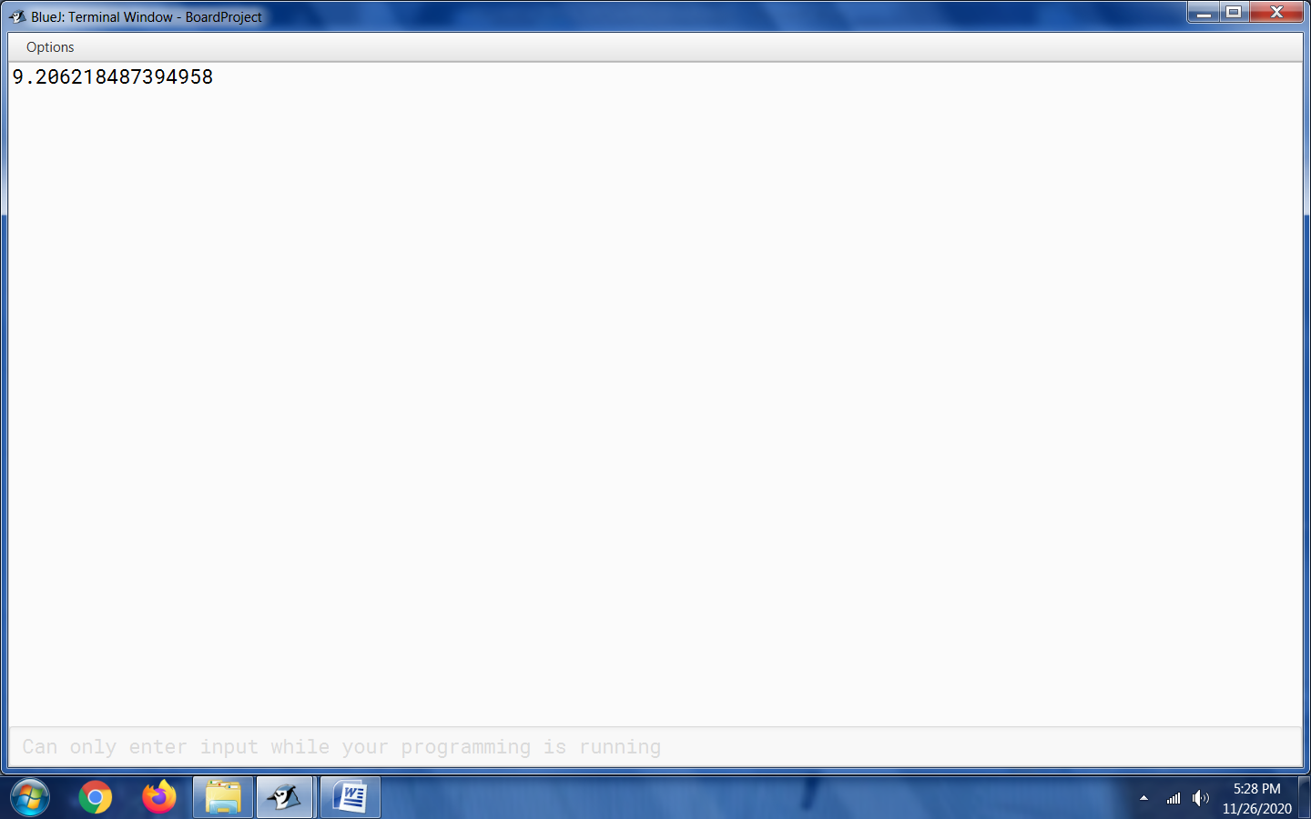

10. Pattern 1 & Pattern 2

* PATTERN 1

public class Question10_Pattern1

{

public static void main(String args[])

{

for(int i=1;i<=5;i++)

{

System.out.print(i);

for(int j =1;j<=i;j++)

{

if (j%2==1)

System.out.print("*");

else

System.out.print("#");

}

System.out.println();

}

}

}

Output:

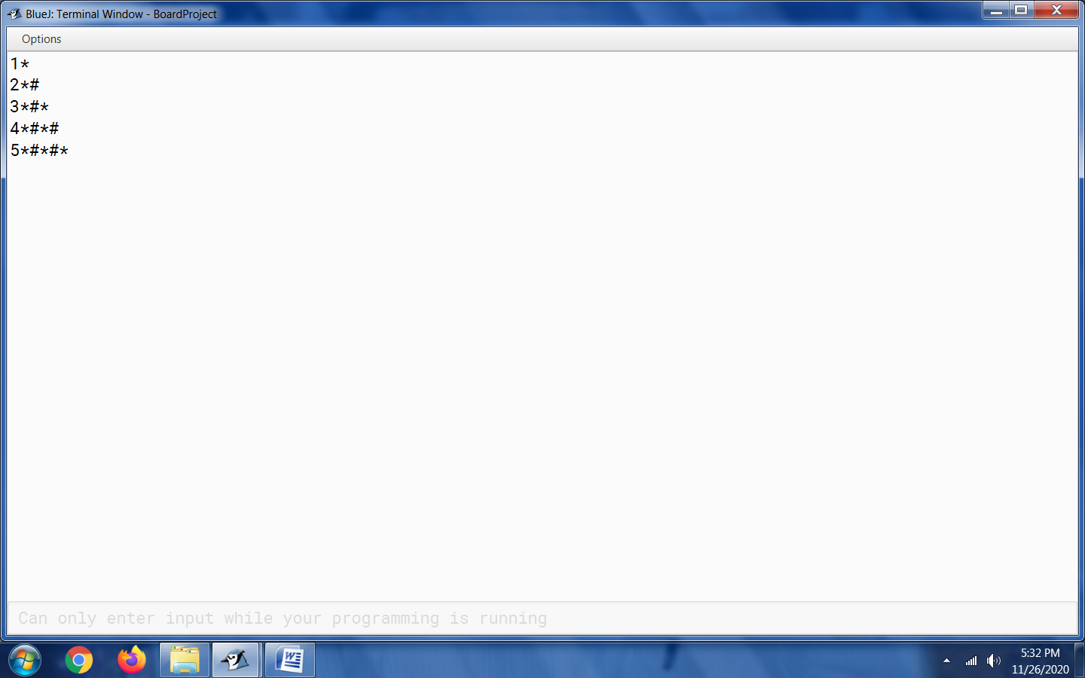

* PATTERN 2

public class Question10_Pattern2

{

public static void main(String args[])

{

for(int i=1;i<=5;i++)

{

for(int j =5;j>=i;j--)

{

System.out.print(j+"");

}

System.out.println();

}

}

}

Output:

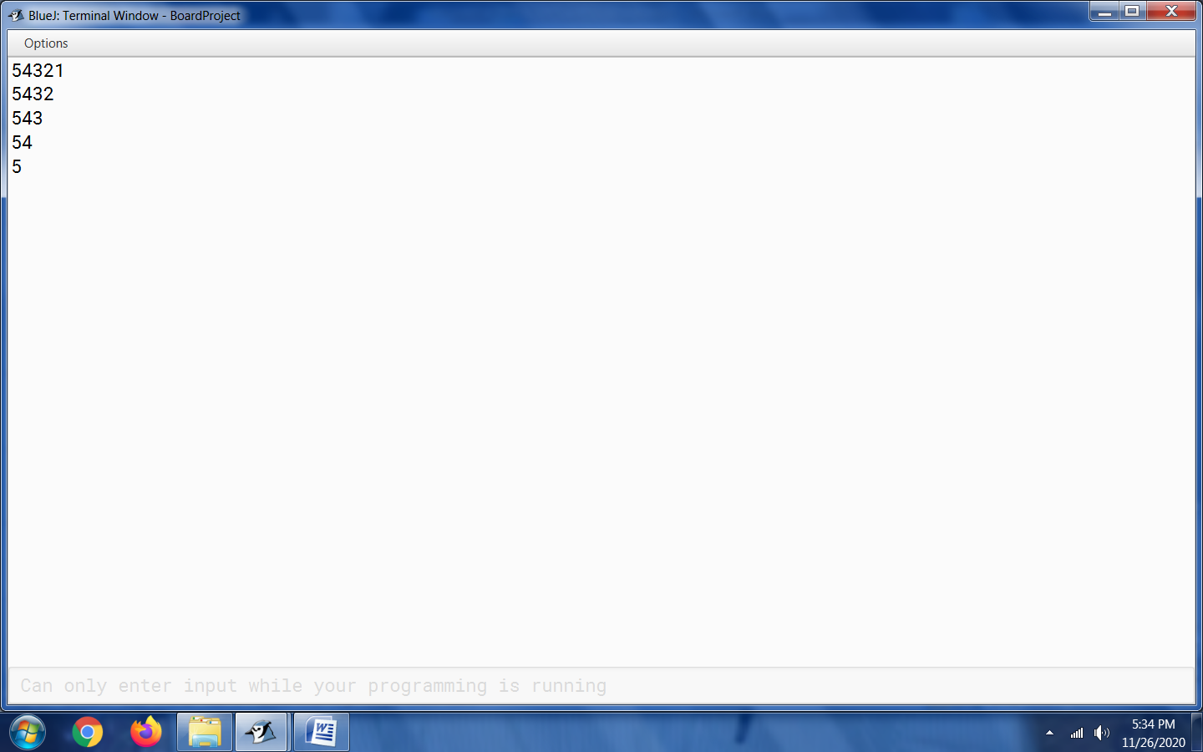

11. Marks

import java.util.Scanner;

public class Question11_Marks

{

public static void main(String[] args)

{

Scanner scanner = new Scanner(System.in);

System.out.print("Enter number of students: ");

int n = scanner.nextInt();

int[] rollNumbers = new int[n];

String[] names = new String[n];

int[] subject1Marks = new int[n];

int[] subject2Marks = new int[n];

int[] subject3Marks = new int[n];

for (int i = 0; i < n; i++)

{

System.out.println("Student " + (i + 1));

System.out.print("Enter roll number: ");

rollNumbers[i] = scanner.nextInt();

System.out.print("Enter name: ");

scanner.nextLine(); // To consume the new line produced on hitting

// enter after entering roll number

names[i] = scanner.nextLine();

System.out.print("Enter marks in subject 1: ");

subject1Marks[i] = scanner.nextInt();

System.out.print("Enter marks in subject 2: ");

subject2Marks[i] = scanner.nextInt();

System.out.print("Enter marks in subject 3: ");

subject3Marks[i] = scanner.nextInt();

}

for(int i = 0; i < n; i++)

{

System.out.println("Roll number = " + rollNumbers[i] + ",

Name = " + names[i]);

int averageMarks = (subject1Marks[i] + subject2Marks[i] +

subject3Marks[i]) / 3;

if (averageMarks >= 85 && averageMarks <= 100)

{

System.out.println("EXCELLENT");

}

else if(averageMarks >= 75 && averageMarks <= 84)

{

System.out.println("DISTINCTION");

}

else if (averageMarks >= 60 && averageMarks <= 74)

{

System.out.println("FIRST CLASS");

}

else if (averageMarks >= 40 && averageMarks <= 59)

{

System.out.println("PASS");

}

else if (averageMarks < 40)

{

System.out.println("POOR");

}

}

}

}

Output

12. Bubble Sort Technique

import java.util.*;

public class Question12_Bubble_Sort_Technique

{

public static void main(String[] args)

{

Scanner sc = new Scanner(System.in);

String[] names = new String[5];

System.out.println("Kindly enter any 5 numbers or letters, you would like to sort: ");

for (int i = 0; i < 5; i++)

{

names[i] = sc.nextLine();

}

for (int i = 0; i < names.length - 1; i++)

{

for (int j = 0; j < names.length - i - 1; j++)

{

if (names[j].compareTo(names[j + 1]) > 0)

{

String temp = names[j];

names[j] = names[j + 1];

names[j + 1] = temp;

}

}

}

System.out.println("Sorted numbers/letters: ");

for (int i = 0; i < names.length; i++)

{

System.out.println(names[i]);

}

}

}

Output 1:

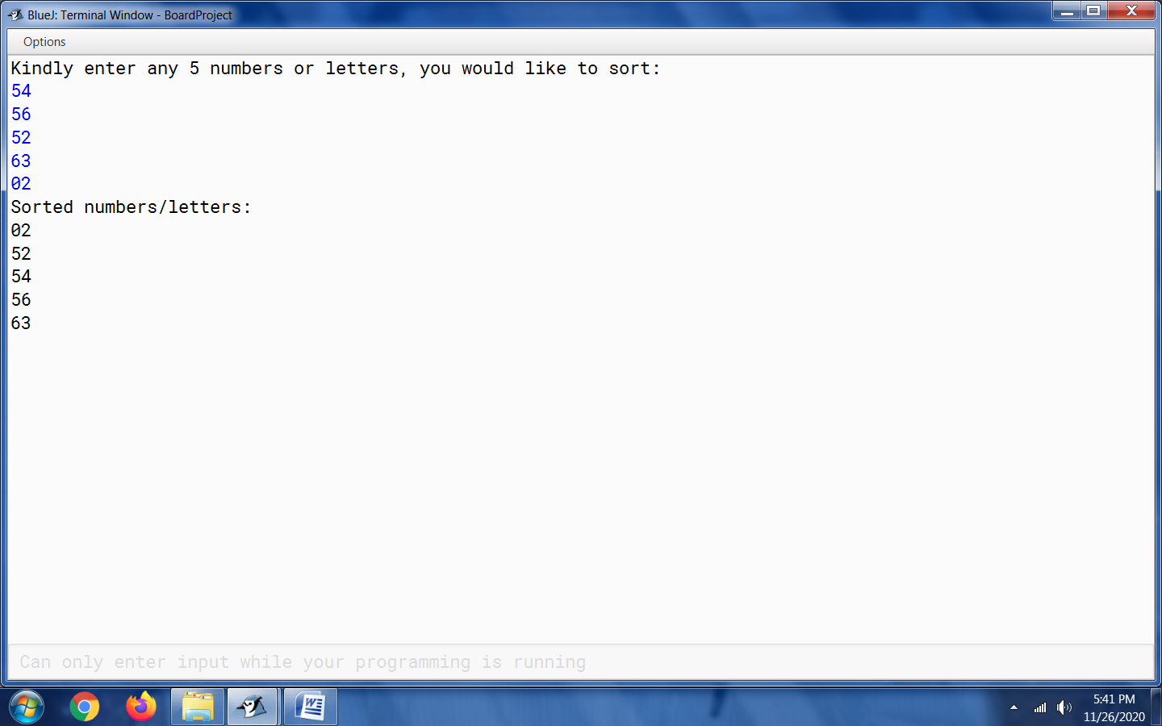

Output 2:

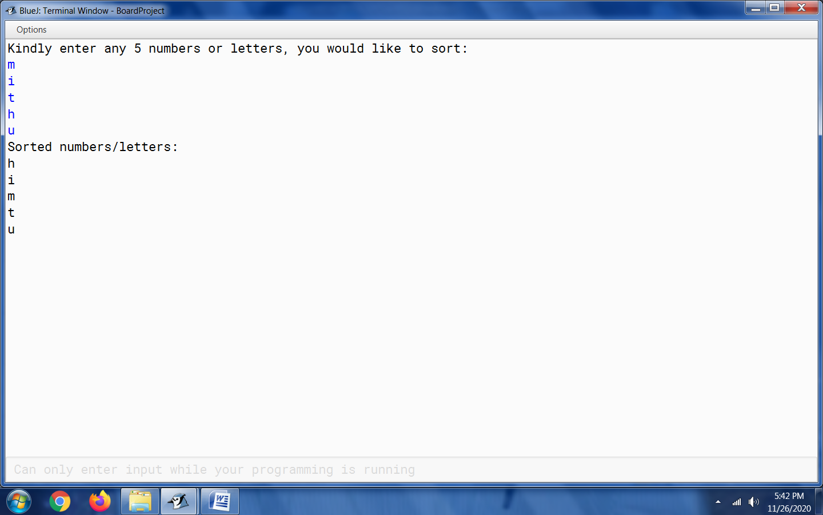

Output 3:

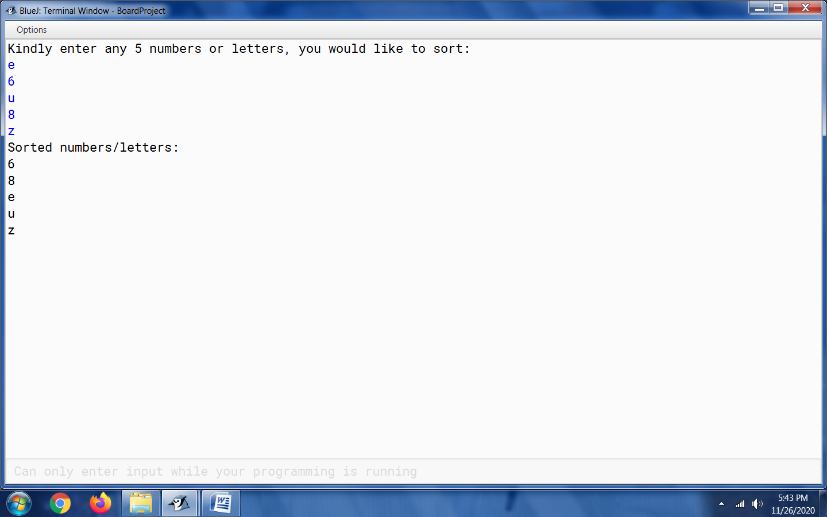

13. Temperature

import java.util.Scanner;

public class Question13_Temperature

{

int [] Temp=new int[8];

void input()

{

Scanner sc=new Scanner(System.in);

System.out.println("Kindly enter the temperature of five different cities of your choice:");

for(int i=0;i<=Temp.length-1;i++)

{

Temp[i]=sc.nextInt();

}

}

void Compare()

{

for(int j=0;j<=Temp.length-1;j++)

{

int temporary;

for(int a=0;a<=Temp.length-2;a++)

{

if(Temp[a]>Temp[a+1])

{

temporary=Temp[a];

Temp[a]=Temp[a+1];

Temp[a+1]=temporary;

}

}

}

}

void display()

{

for(int x=0;x<=Temp.length-1;x++)

{

System.out.print(Temp[x]+" ");

}

}

public static void main()

{

Question13_Temperature obj=new Question13_Temperature();

obj.input();

obj.Compare();

obj.display();

}

}

Output 1:

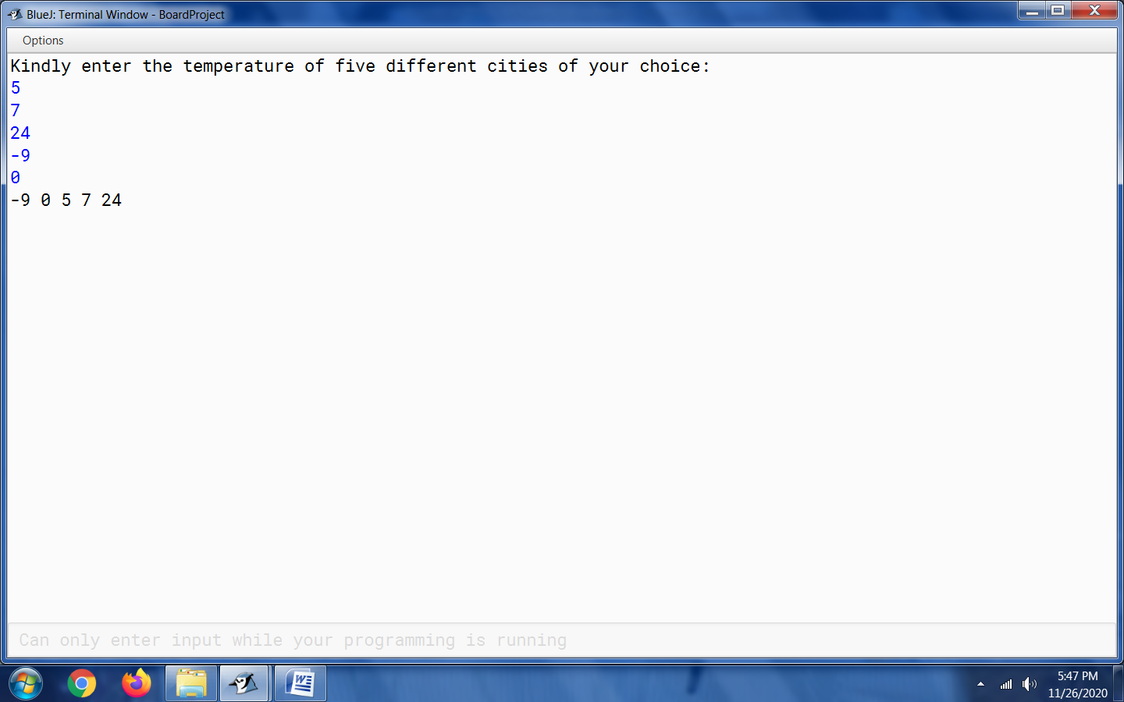

Output 2:

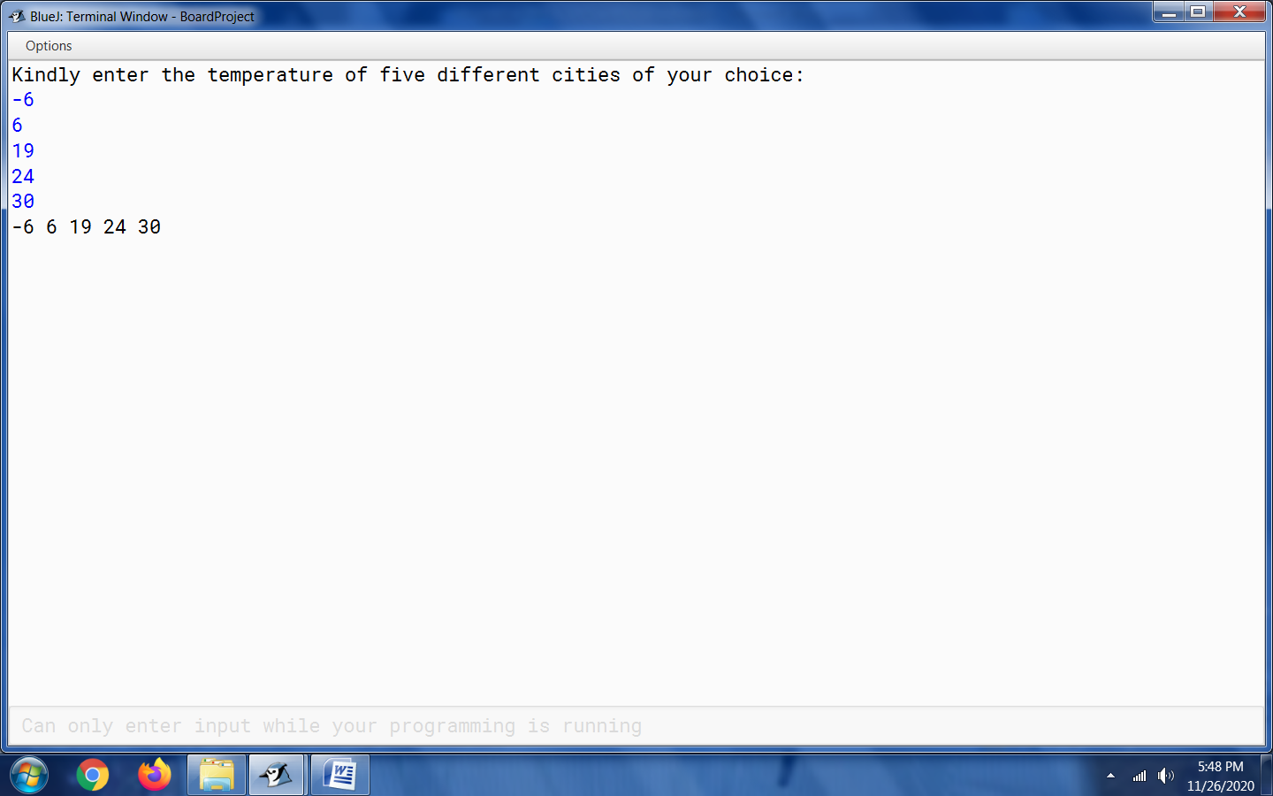

14. Average

import java.util.Scanner;

public class Question14_Average

{

double [] Array_num ;

double sum=0;

double avg;

Question14_Average(int arraysize)

{

Array_num=new double[arraysize];

}

void input()

{

Scanner sc=new Scanner(System.in);

System.out.println("Kindly enter any ten numbers");

for(int i=0;i<=Array_num.length-1;i++)

{

Array_num[i]=sc.nextDouble();

}

}

void Calculate()

{

for(int j=0;j<=Array_num.length-1;j++)

{

sum= sum+ Array_num[j] ;

}

avg=sum/10;

}

void display()

{

for(int j=0;j<=Array_num.length-1;j++)

{

if(Array_num[j]>avg)

{

System.out.println(Array_num[j]);

}

}

}

public static void main()

{

Question14_Average obj=new Question14_Average(10);

obj.input();

obj.Calculate();

obj.display();

}

}

Output 1:

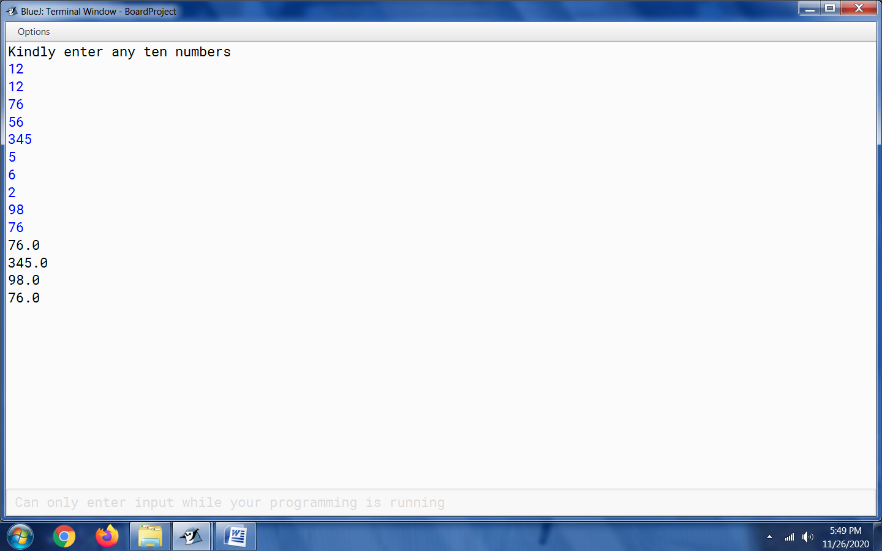

Output 2:

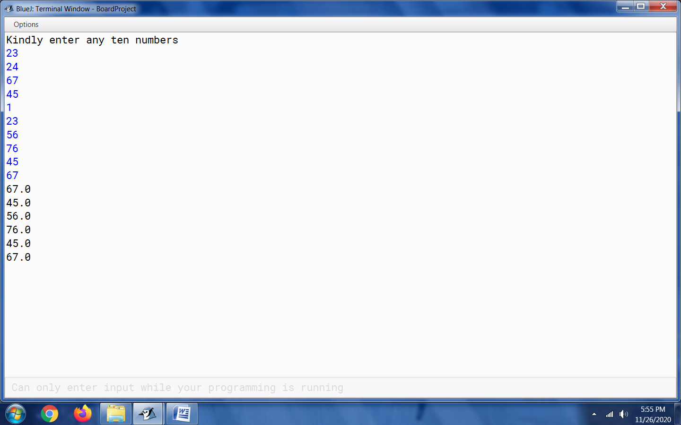

15. Last Digit

import java.util.Scanner;

public class Question15_Last_Digit

{

int [] AW ;

int temp;

Question15_Last_Digit(int arraysize)

{

AW=new int[arraysize];

}

void input()

{

Scanner sc=new Scanner(System.in);

System.out.println("Please enter 8 numbers of your choice");

for(int i=0;i<=AW.length-1;i++)

{

AW[i]=sc.nextInt();

}

}

void Calculate()

{

for(int j=0;j<=AW.length-1;j++)

{

temp=AW[j]%10;

if(temp==3)

{

System.out.println(AW[j]);

}

}

}

public static void main()

{

Question15_Last_Digit obj=new Question15_Last_Digit(8);

obj.input();

obj.Calculate();

}

}

Output 1:

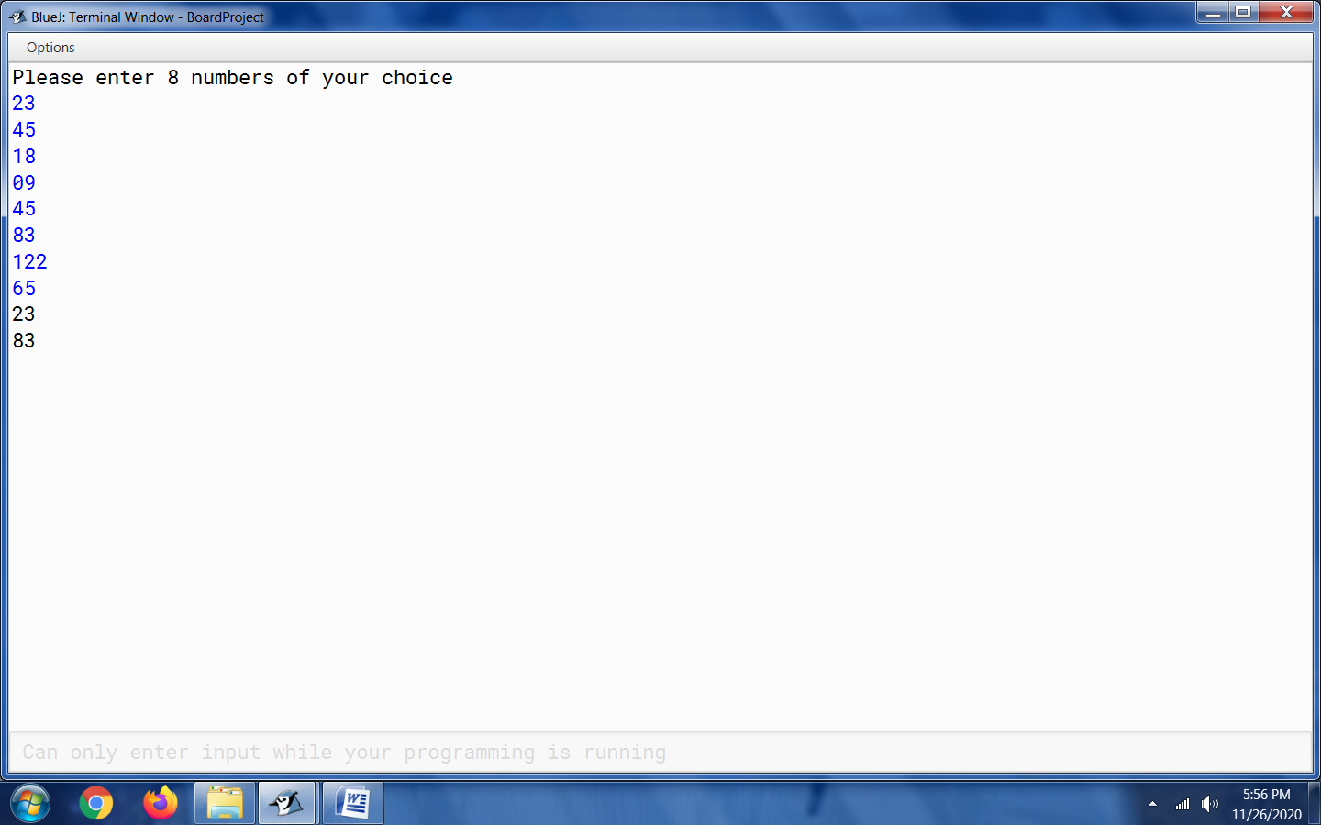

Output 2:

